1) SELECT first_name, last_name FROM employees WHERE salary > ( SELECT salary FROM

employees WHERE employee_id=163 );

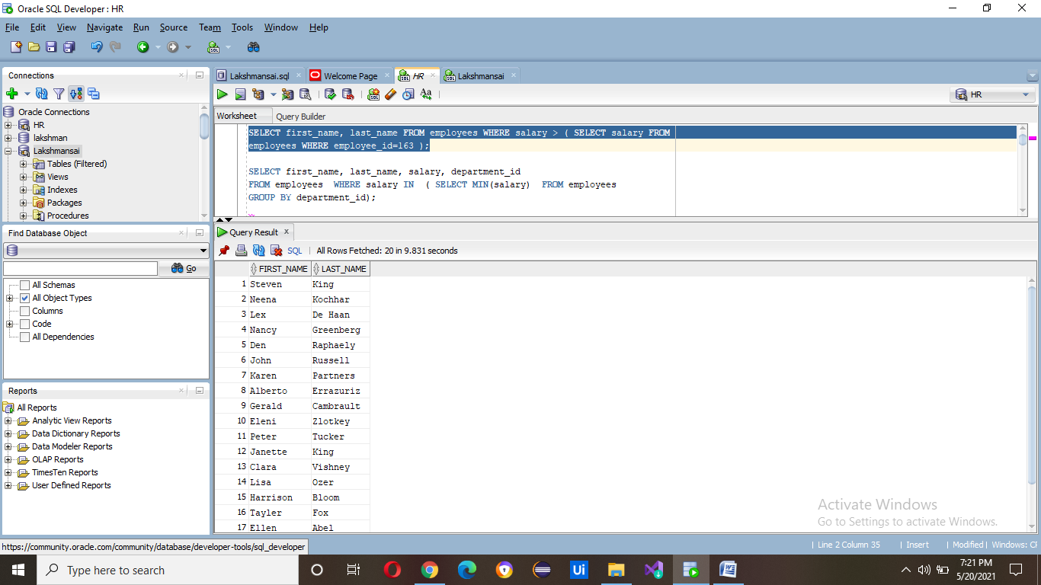

2) SELECT first_name, last_name, salary, department_id

FROM employees WHERE salary IN ( SELECT MIN(salary) FROM employees

GROUP BY department_id);

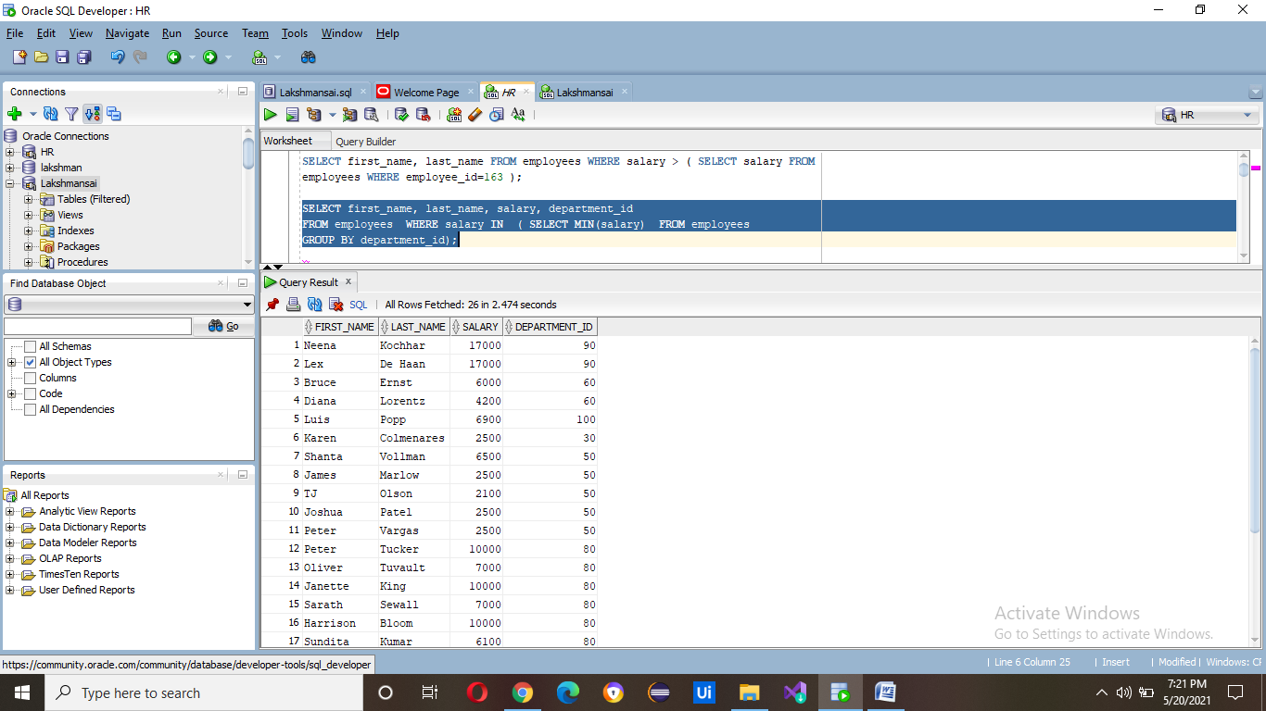

3) SELECT e.department_id, e.first_name, e.job_id , d.department_name

FROM employees e , departments d

WHERE e.department_id = d.department_id

AND d.department_name = 'Finance';

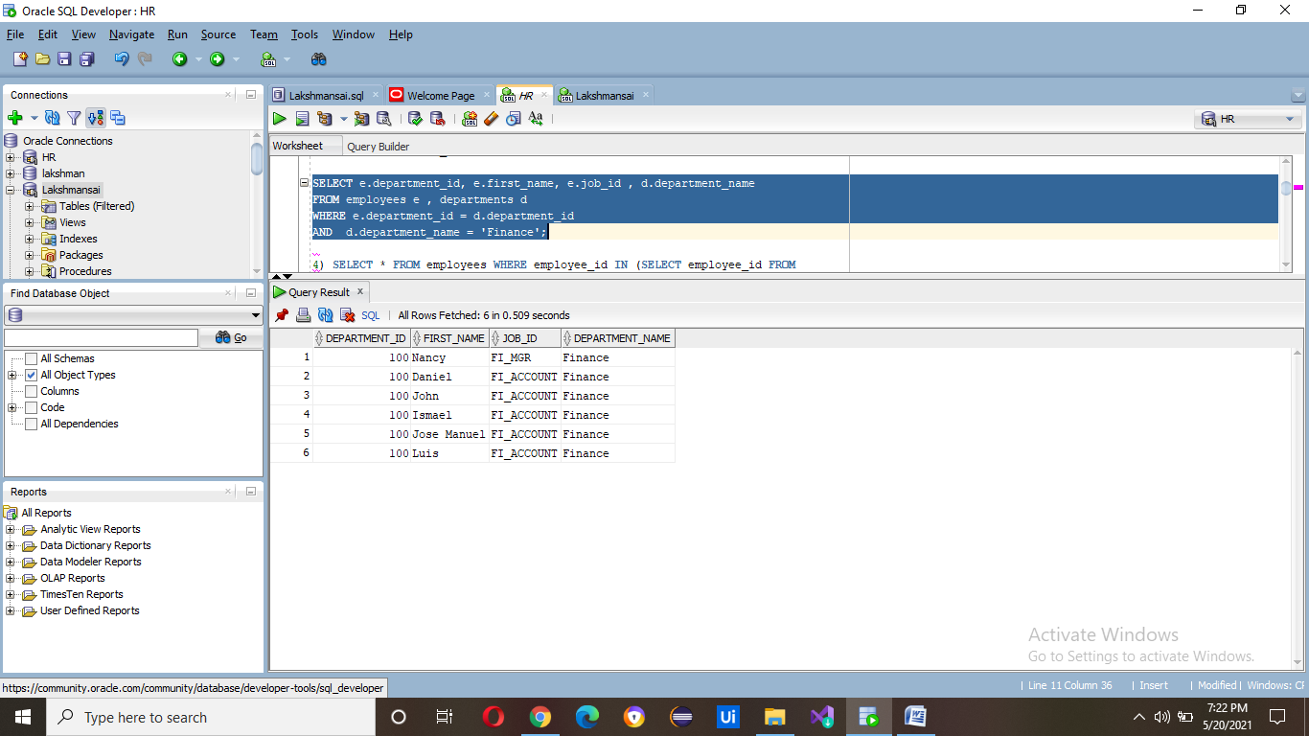

4) SELECT * FROM employees WHERE employee_id IN (SELECT employee_id FROM employees WHERE salary = (SELECT MAX(salary) FROM employees WHERE salary < (SELECT MAX(salary) FROM employees)));

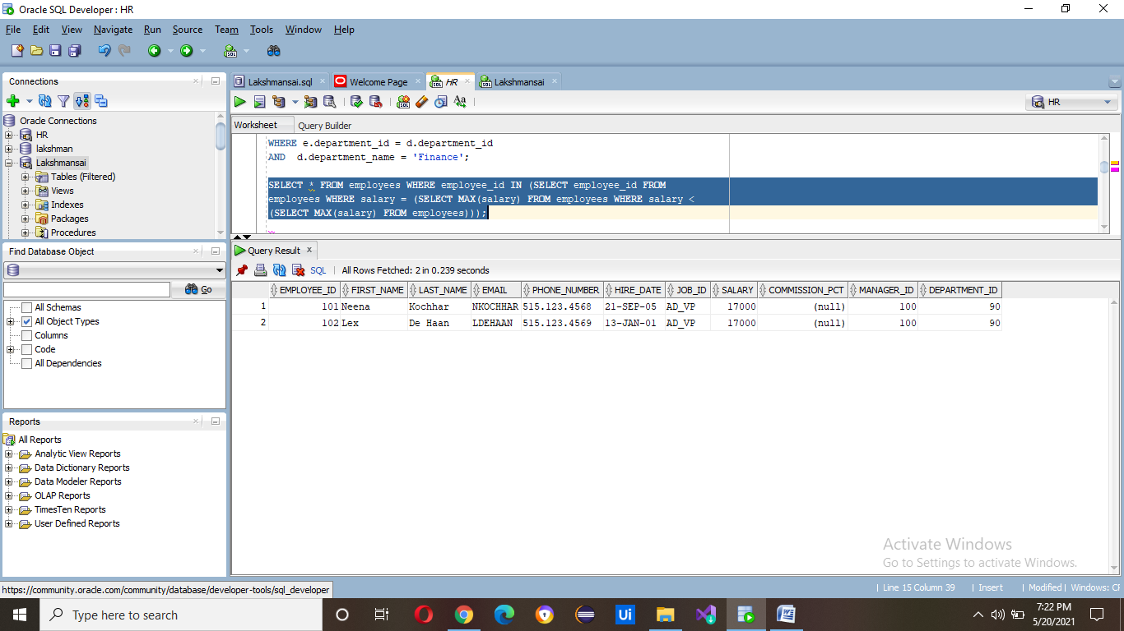

5) SELECT employee_id, first_name , salary FROM employees WHERE salary >

(SELECT AVG (salary) FROM employees ) AND department_id IN ( SELECT

department_id FROM employees

WHERE first_name LIKE '%J%');

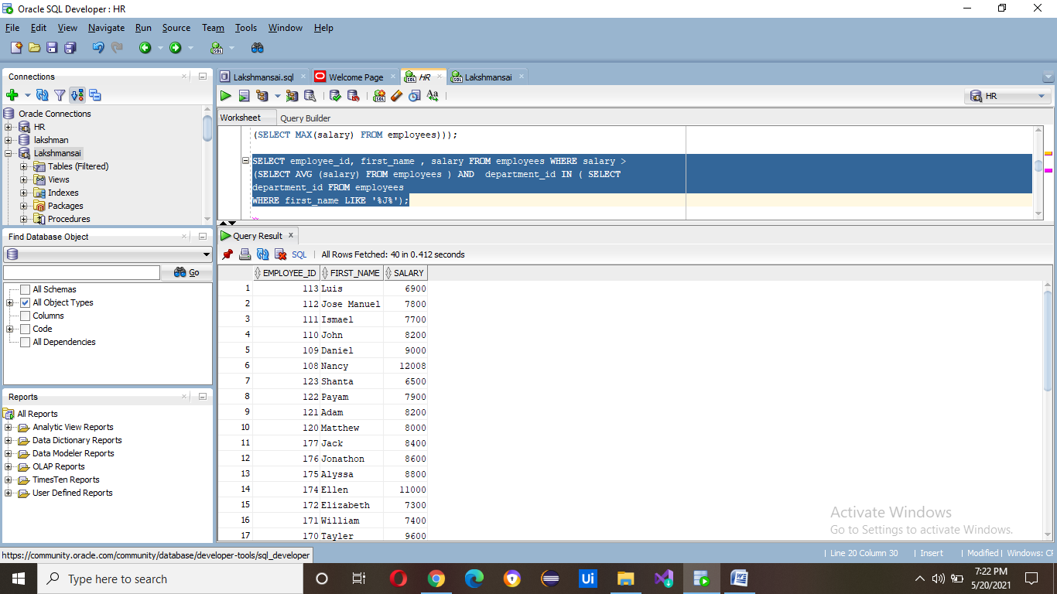

6) SELECT employee_id,first_name,last_name, job_id FROM employees WHERE

salary < ANY ( SELECT salary FROM employees WHERE job_id = 'MK_MAN' ) ;

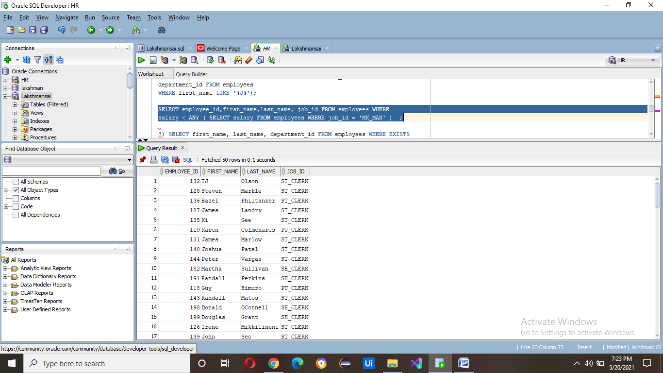

7) SELECT first_name, last_name, department_id FROM employees WHERE EXISTS

(SELECT * FROM employees WHERE salary >3700 );

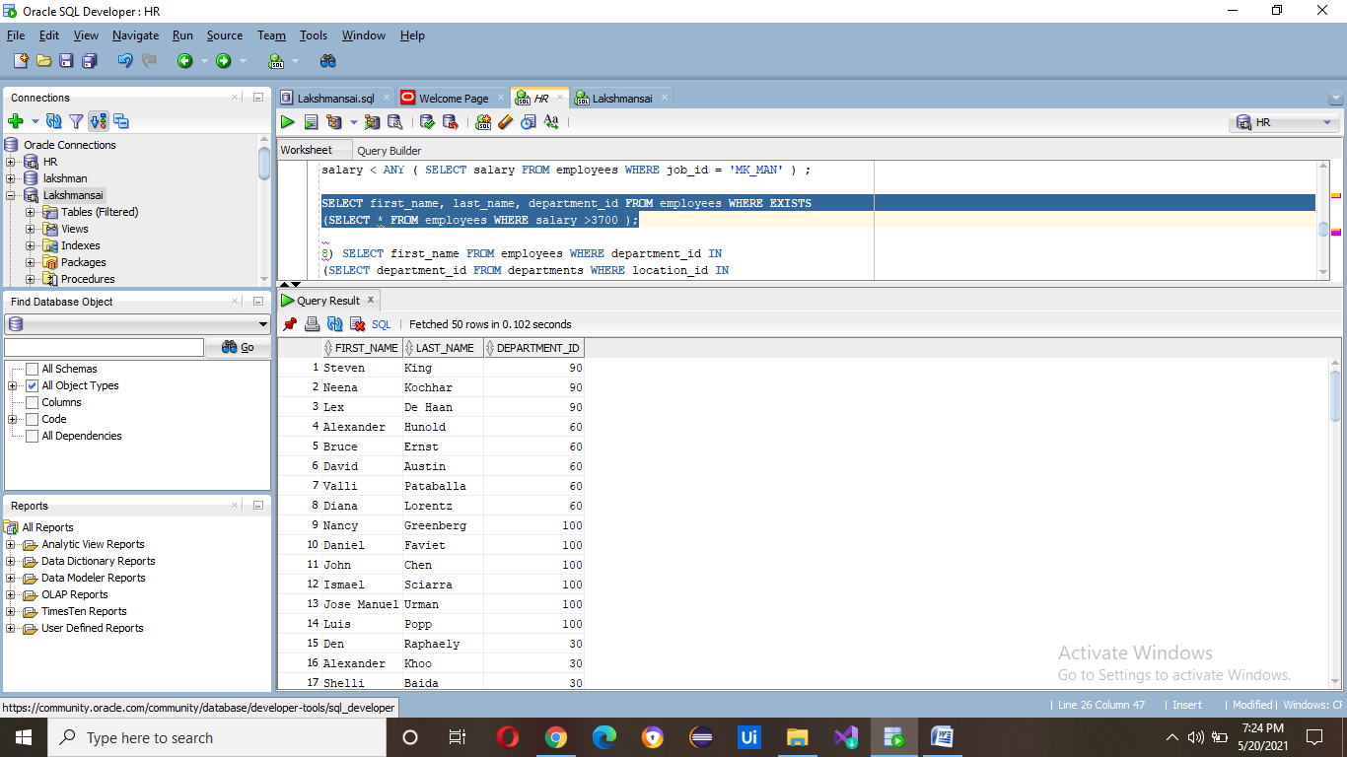

8) SELECT first_name FROM employees WHERE department_id IN (SELECT department_id FROM departments WHERE location_id IN

(SELECT location_id FROM locations WHERE country_id = (SELECT country_id FROM countries WHERE country_name='United Kingdom')));

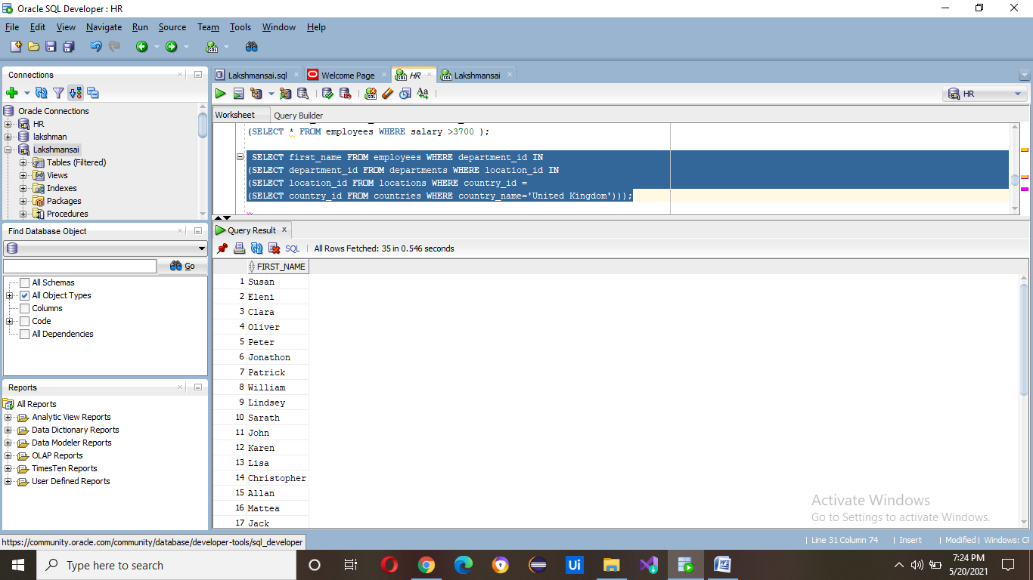

9) SELECT * FROM employees WHERE employee_id=ANY ( SELECT manager_id FROM departments );

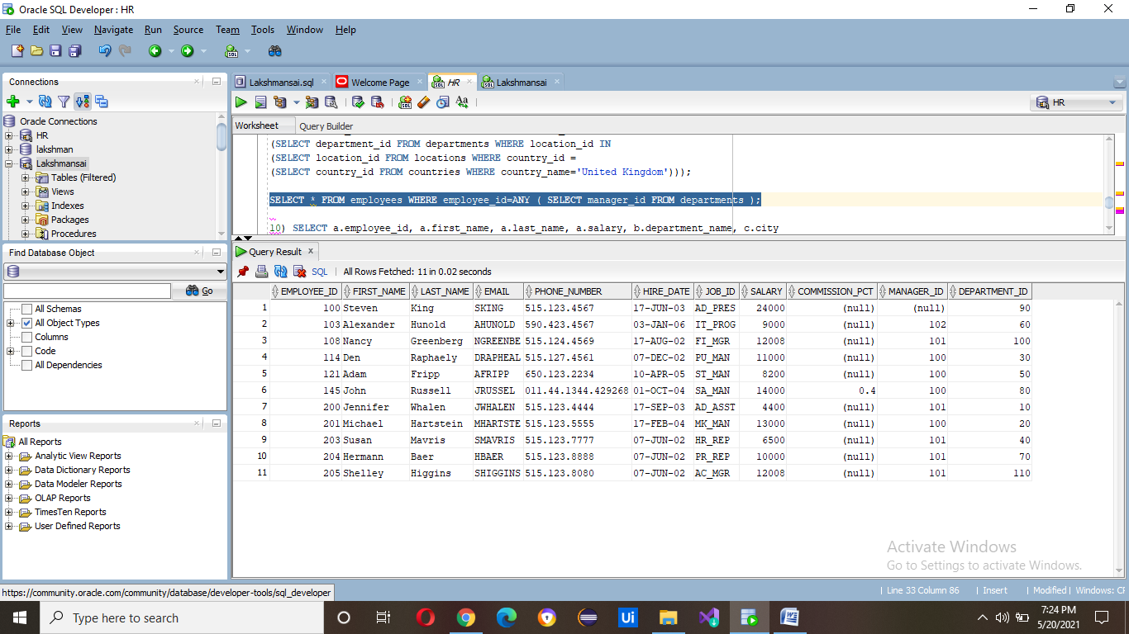

10) SELECT a.employee_id, a.first_name, a.last_name, a.salary, b.department_name, c.city

FROM employees a, departments b, locations c

WHERE a.salary = (SELECT MAX(salary)

FROM employees

WHERE hire_date BETWEEN '01/jan/2002' AND '31/dec/2003')

AND a.department_id=b.department_id

AND b.location_id=c.location_id;

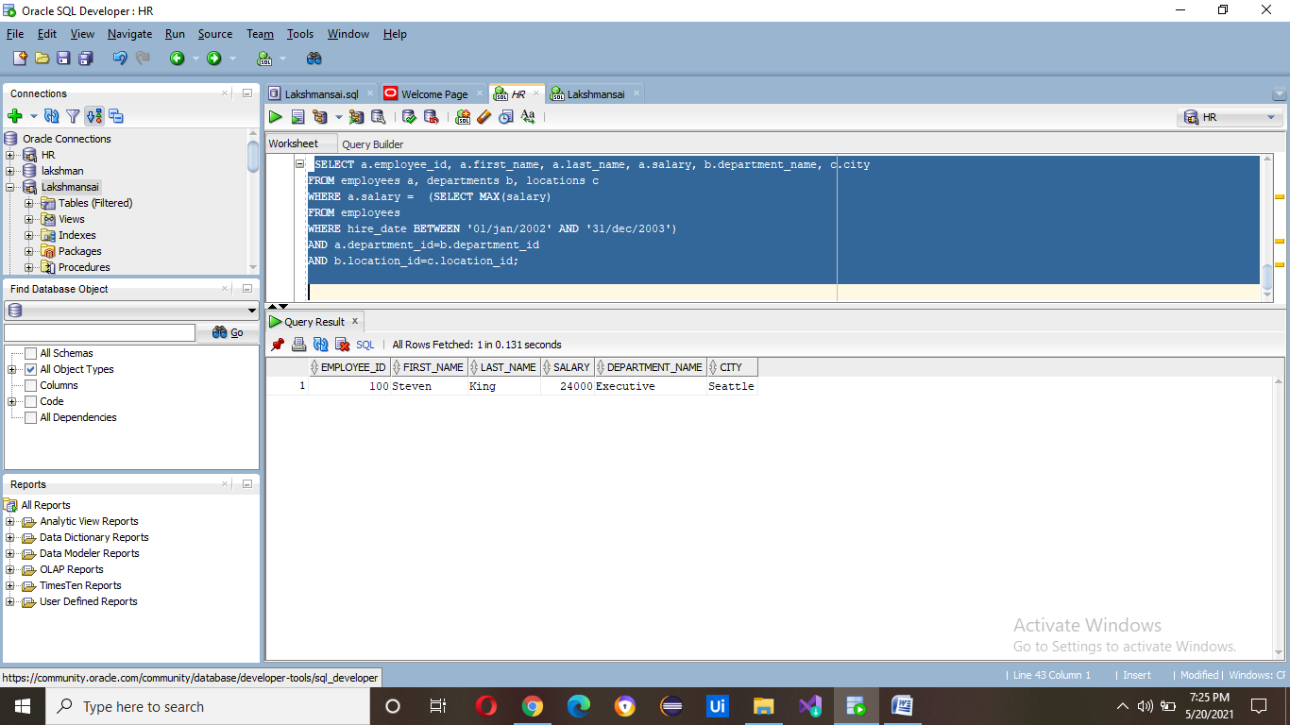

Assignment 1:-23 to 40

select * from emp where empno not in(select mgr from emp where mgr is not null);

select ename from emp where job not in('clerk','salesman','analyst');

select count(*) from emp;

select sum(sal)+sum(nvl(comm,0))from emp;

select max(sal)from emp;

select min(sal)from emp;

select avg(sal)from emp;

select max(sal)from emp where job='clerk';

select max(sal) from emp where deptno=20;

select min(sal)from emp where job='salesman';

select avg(sal)from emp where job='manager';

select sum(sal)+sum(nvl(comm,0))from emp where deptno=40;

select ename from emp order by sal;

select ename from emp order by sal desc;

select ename from emp order by ename;

select ename,empno,deptno,sal from emp order by ename;

select ename,12*(sal+nvl(comm,0))annual from emp order by

12*(sal+nvl(comm,0))desc;